Flash video player v0.1
Lawrence Botley
20th October 2007

Overview
The player will be embedded into the video player page and allow users to watch a video from a link clicked on the previous page. Once the page loads the flv URL should be passed in as a parameter within the HTML and the video play automatically.
During the video a small popup advert will be displayed in the bottom half of the screen, the user may wish to click the popup which will launch a new window and take the user to a specified link. After a set number of seconds (or if the user clicks the close button on the advert) the popup window will hide itself again. The details of the popup will be obtained via a web service.
During the play of the video another web service will be called (passing in the videoID as a parameter) and will return a number of video links that will be displayed to the user once the video has finished playing. Should a user click on one of the links, the browser will forward the user to that page.
Please Note that the web services will up and running by Thursday 25th of October 2007.
Summary:
- Plays progressive or streamed video from HTML parameter
- Obtains adverts data via web service and displays it at the designated interval (configurable)
- Obtains alternative video link via web service and displays them at the end of the video

This document is broken down into the following sections

- Video Player specification
- Video player functionality
- Video player control panel
- Adverts
- Finished video screen
- Alternative video suggestions
- Similar web video sites
- Video Player specifications

Video source resolution is 320x240 pixels but will be scaled up to 480 x 365 for normal mode and full screen for full screen mode

- Scaled up video in normal mode - 480 x 365
- Total dimensions of video player controls 480 x 35
- Total dimensions and width of video player including player controls - 480 x 400

2.0 Basic video player functionality

The player should be adapted from JW Player (http://www.jeroenwijering.com/?item=JW_FLV_Player) where all of the players functionality has already been developed. These functions include:

- Play > Pause > Replay from start
- Back to beginning
- Volume control
- Full-screen toggle
- Display video duration/current play point
  - Video scrub forwards/backwards

- Video player control panel

The player control panel allow the users to navigate through the video, adjust the volume and toggle full-screen mode

Figure 2.1 is a mash-up of several video players on the web and by no means is near the design we are looking for. You may choose your own design and the colours should be light greys as we don’t want it to be too overpowering. Please see www.next2friends.com for our colours.

Once the video is playing, the play button icon will become a pause button icon. When it is pressed, the video will be paused. Click again will resume the video.

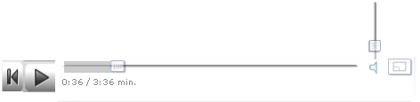
Figure 2.1 – mashup of the approximate layout of the player control panel
4.0 Adverts

Adverts are small popups that animate upwards into the screen from the bottom and displayed at around 20 seconds into the video. The adverts are displayed for 5 seconds before they retreat back downwards until out of site. For a good example of this please watch a video on metacafe.com as this is almost the exact style which we wish the player to encompass.

Diagram 4.1 is a screen shot from metacafe.com and whilst the colour of the background (purple) is to be changed, the remaining features including layout should be identical. This include:

- Image for the advert
- The title text (displayed in colour A)
- Description text displayed in colour B
- Hyperlink text displayed in colour A
- A close button which will immediately animate the popup out of site
- The active hyperlink area that will launch a new window if the user clicks

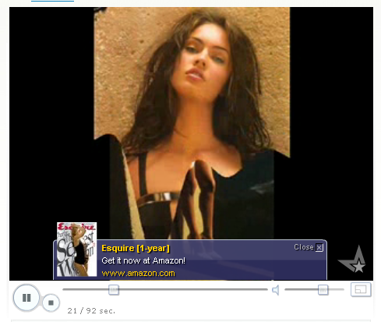
Image up to 70x70 Pixels
Title text (up to 30 characters)
)
3. Description text (up to 60 characters)
Hyperlink click thorough
Close Button instantly hide advert popup box
Hyperlink active area
Figure 4.1 – Metacafe popup layer should almost exactly resemble Next2Friends.com

In order for the player to obtain the advert, the SWF file must first pass a number of parameters to a web service. These parameters are originally passed in as HTML parameters into the SWF object and include

- MemberID of the user. Empty string if no user is logged in
- The VideoID of the current playing video

Once these parameters have been submitted to the web service, the web service will pass back 6 values

- Show - boolean - Should the popup be displayed (if false the rest of the parameters will be blank and the advert will not show)
- Image URL – string – The URL to fetch the advert thumbnail from
- Title – string - The title of the advert
- Description – string – the description text
- HyperLink – string the link to clickthrough if the user clicks on the link
- HyperLinkText – string – the text to wrap the hyperlink in

Future development will include displaying many adverts throughout the duration of the video so please bear this in mind when designing this section of the player.

5.0 Finished video screen

Once the video has finished playing the player will display a number of features.

- An icon and text to replay the video
- A list of 4 videos including thumbnail and video title
- Another advert will be statically placed at the bottom of the video display panel
- The last frame of the video is alpha faded out to a suitable level for easy viewing

Note: The play button icon on the player control panel will also change to a replay icon

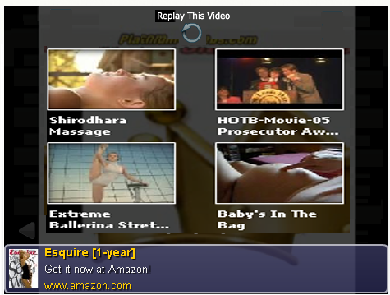
Replay the video

Alternative video suggestions

Advert with click through link

Alpha fade final frame

Figure 5.1 Final screen when video finishes playing

Before 10% (or there abouts) before the video finishes playing the following operations will take place

- Make web service [section 4.0]call to obtain advert
- Make web service [section 6.0] call to obtain alternative video suggestions

This will ensure that when the video has finished playing, the necessary resources (text and thumbnails) will be cached in the browser and ready to be displayed.

For examples of this kind of screen please view a video all the way through on youtube.com, break.com, metacafe.com or livevideo.com.

Final note on the alternative video suggestions: When a user mouses over, the video shall be subtly highlighted along with its title.

6.0 The alternative video web service

The alternative video suggestions work in very similar ways to the Advert web service and pass in two parameters.

- MemberID of the user. Empty string if no user is logged in
- The VideoID of the current playing video

Once these parameters have been submitted to the web service, the web service will pass back 6 values

- An array of 4 thumbnail image URL
- An array of 4 video titles
- An array of 4 video click through links

James: Please can you let me know of the best data-structure suitable for returning these values. I can make them a SOAP object or a simple jagged array.

Future development will include allowing the user to scroll backwards and forwards to view many alternative suggestions.

7.0 Similar web video sites

- http://www.youtube.com
- http://www.break.com
- http://www.metacafe.com
- http://www.livevideo.com
- http://video.nationalgeographic.com/video/player/animals/reptiles-animals/alligators-crocodiles/crocodile_nile_wateringhole.html

